CLIENT SIDE MODULE

CONTENTS
This module has the following files:
- CLIENT SIDE MODULE.docx
- CLIENT SIDE MODULE.pdf
- CLIENT SIDE MODULE MEDIA.zip

PROJECT OVERVIEW
A client requires a connection visualizer that can display nodes and find the shortest path between them. The application should be interactive, allowing users to zoom, pan, and click on nodes to access various functionalities. The website must be compatible with modern web browsers and mobile devices.

This module is a 4-hour competition task. You are required to develop a web-based application using only HTML, CSS, and JavaScript. The core functionality revolves around an interactive network of nodes, allowing users to add and connect nodes, as well as find routes between them. You are encouraged to improve the usability and user interface for a better user experience.

Initial User Interface
On initial page load, the user should see an empty grid and a single top bar with several menu options: Save Image, Find Path, Connect, Delete, and Clear.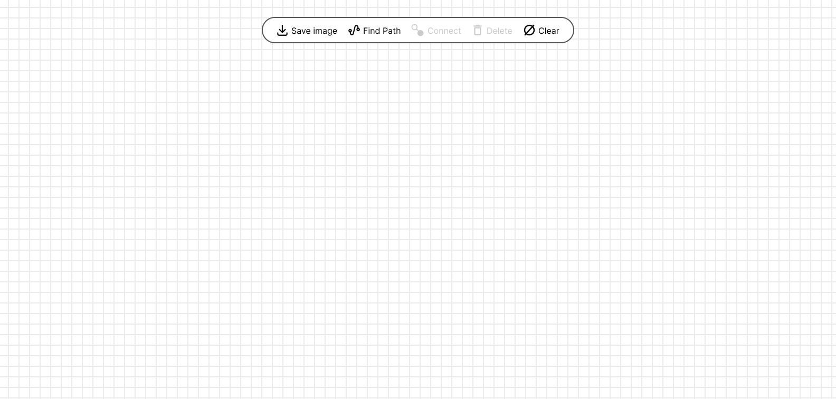

Create Node
The user can create a node by double-clicking the canvas area. A form to create a node should appear near the cursor.

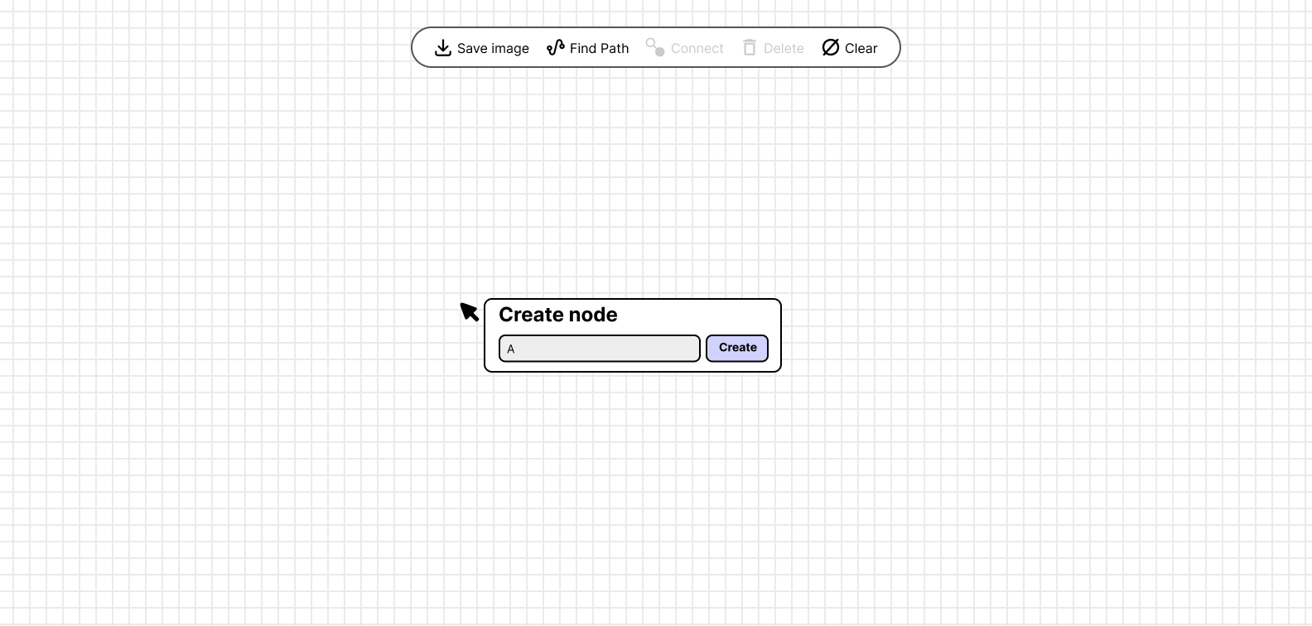

After the user enters the node text and clicks the Create button or presses Enter on the keyboard, the node should be created and appear at the cursor's position.

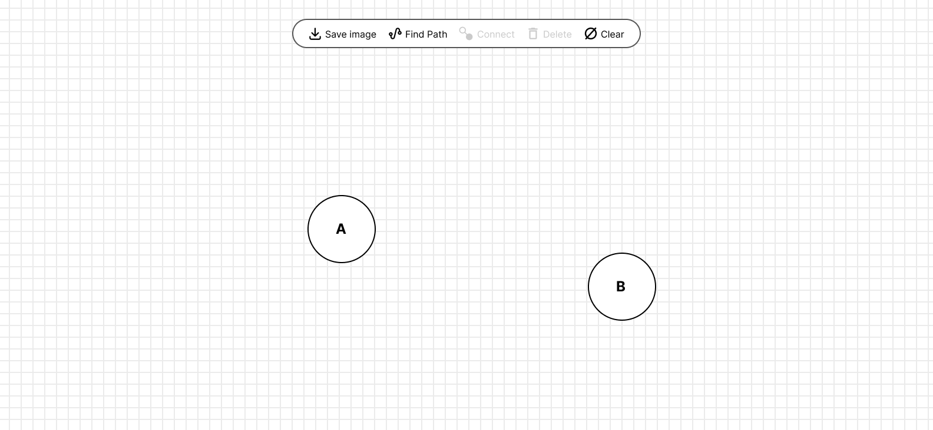

Move Node
The user should be able to move a node by dragging it along with the cursor's movement.

Select Node
When a user clicks a node, the node circle and its label turn blue to indicate it is selected.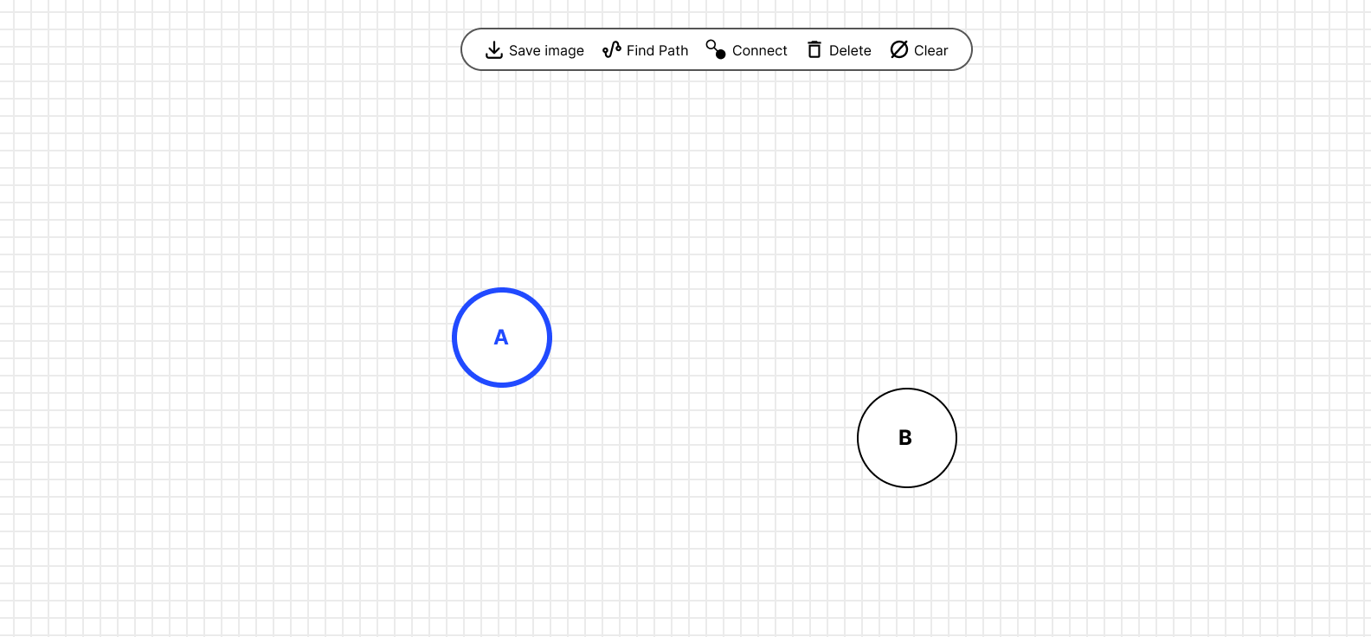

Connect Node
To connect nodes to each other, a node must be selected first. When a node is selected, the "Connect" menu in the top bar becomes enabled. After clicking the "Connect" menu, the "Choose target node" prompt should be visible to the user.
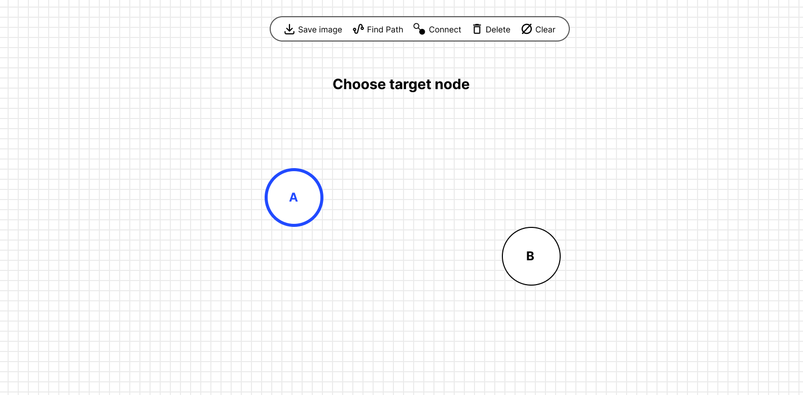

Clicking another node will display a pop-up prompting the user to input the distance between the nodes. The distance must be a number. Clicking the Connect button will apply the connection, and the distance will be shown beside the connector line.
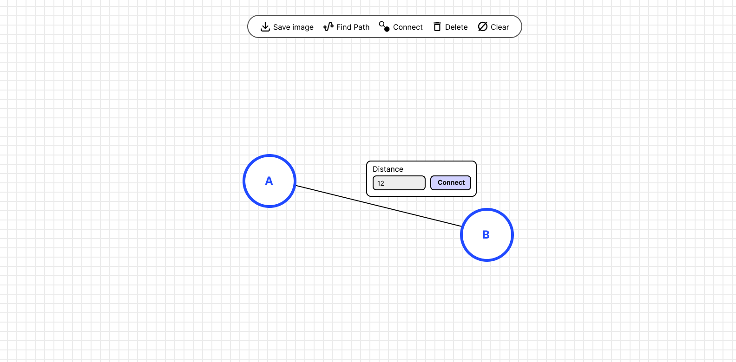

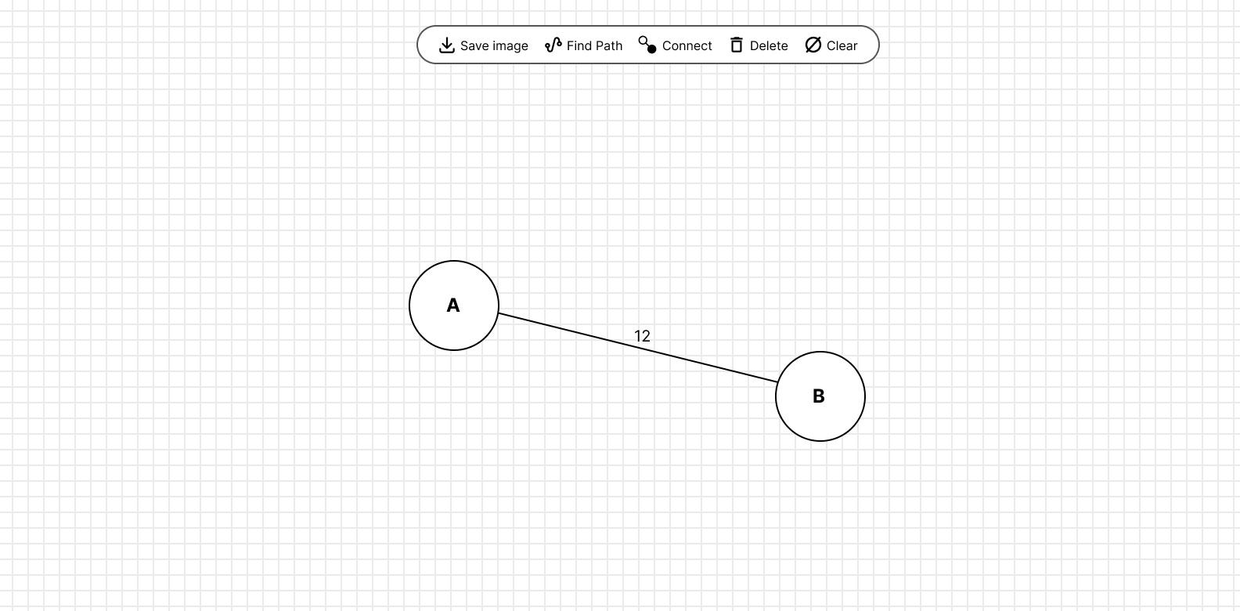

Delete Node
When a node is selected, clicking the Delete menu in the top bar or pressing Backspace on the keyboard should remove the node and its connections.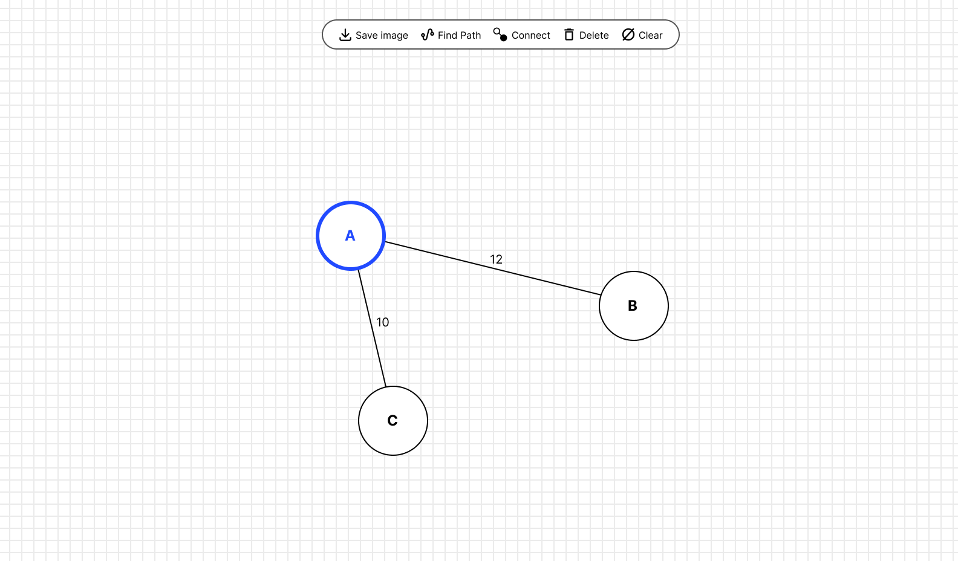

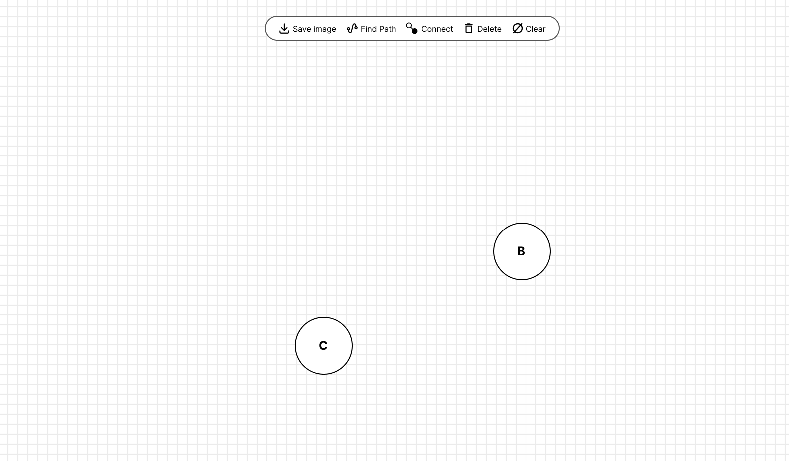

Clear Node
When “Clear” menu on the top bar is clicked, it will remove all nodes and connections.

Path finding
Within a connected network of nodes, the user should be able to find the shortest path from one node to another. For example, to find the path from node A to node E, the user selects node A, clicks the Find Path button in the top bar, then clicks node E.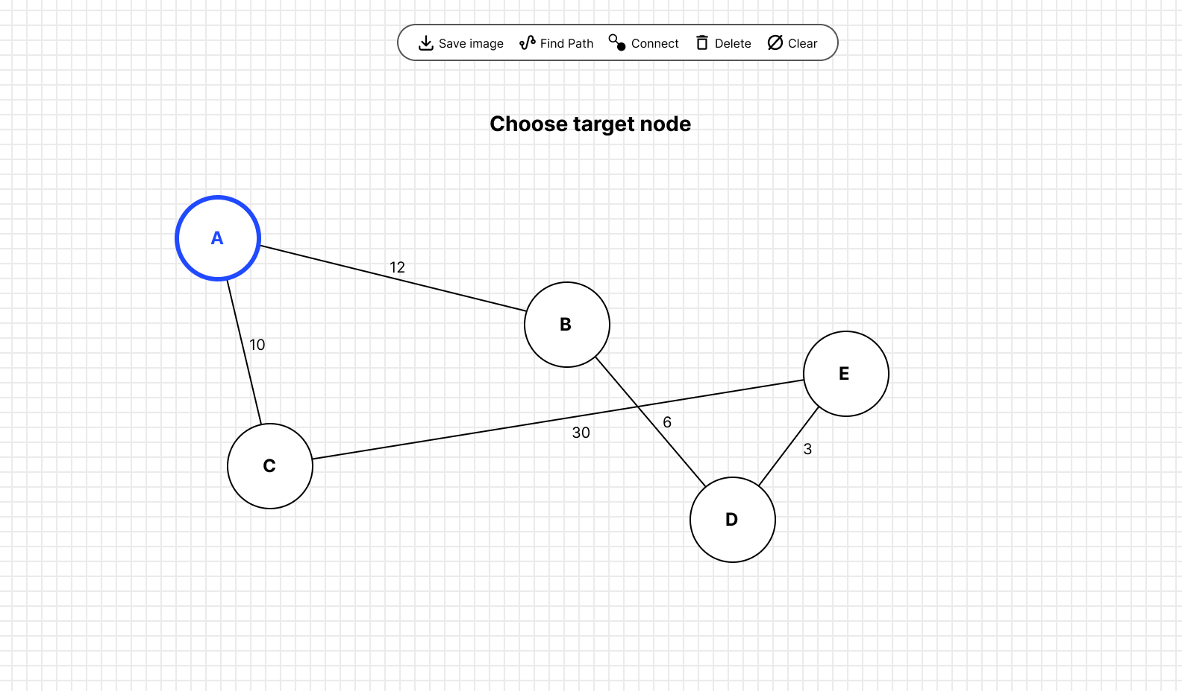

When the path is found successfully, the nodes and lines along the path should be highlighted in blue.

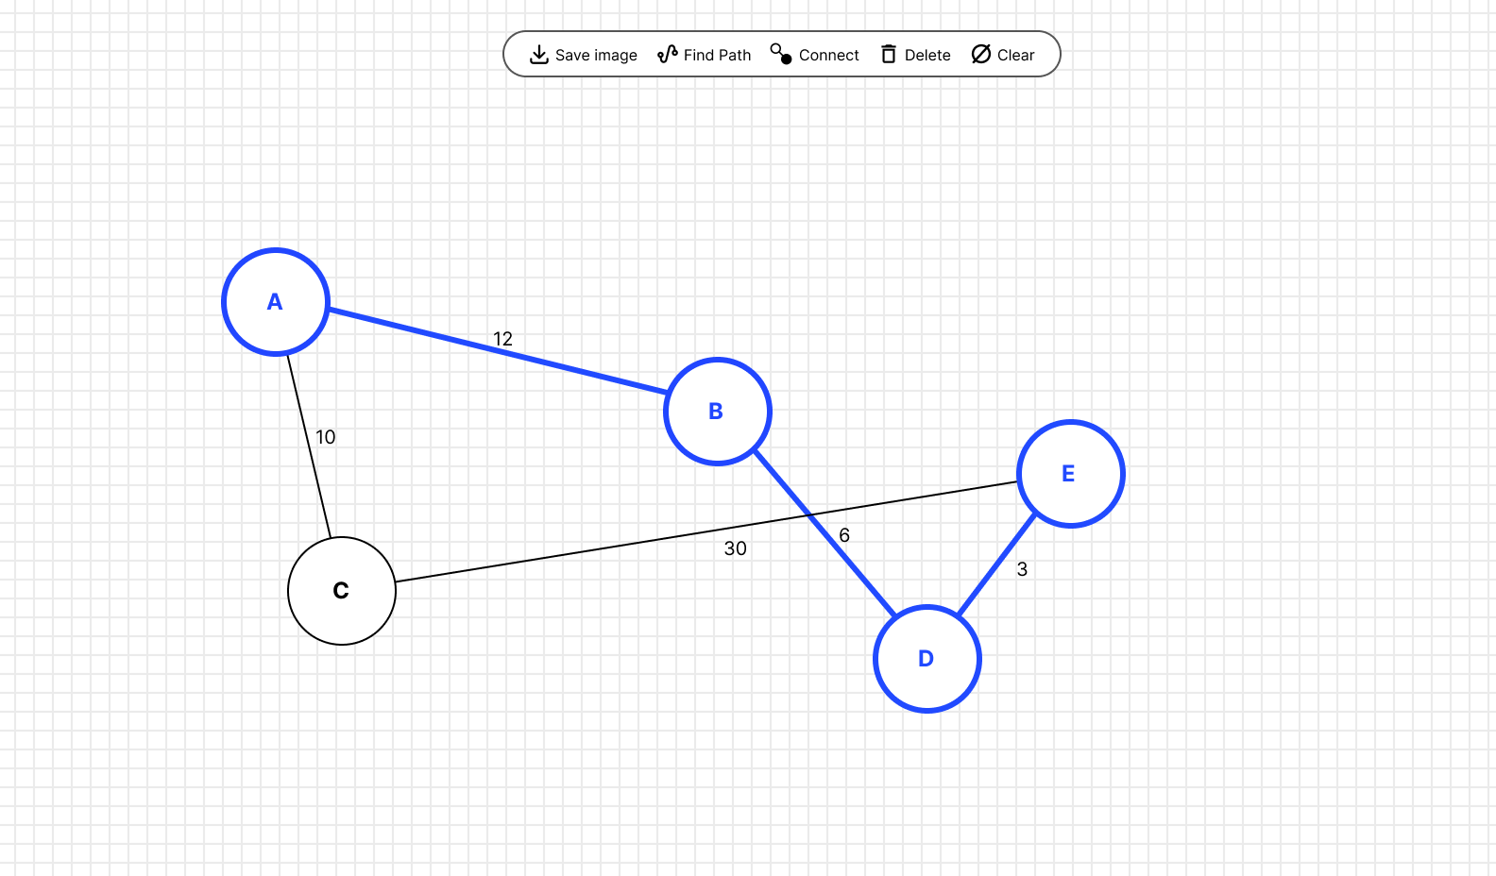

Clicking anywhere on the grid removes the highlight and returns the nodes and lines to their default color.

Pan and zoom
Clicking and holding while moving the cursor shifts the positions of all nodes along with the cursor movement.

Scrolling while holding the Ctrl key will zoom in or zoom out, centered on the cursor's position.

Save to Image
Clicking the "Save Image" button will automatically download the entire canvas as a PNG or SVG file named result.png or result.svg.

Node Persistence
Reloading the page should retain existing nodes and their connections. You may save the data to local storage for persistence.

INSTRUCTION FOR COMPETITORS
- Create a root folder called XX_MODULE_CLIENT in your local computer, where XX is your computer number.
- Place your works inside the root folder. Make sure your works are working well when directly opening the index.html file.
- Zip your root folder XX_MODULE_CLIENT and submit to the submission page.

